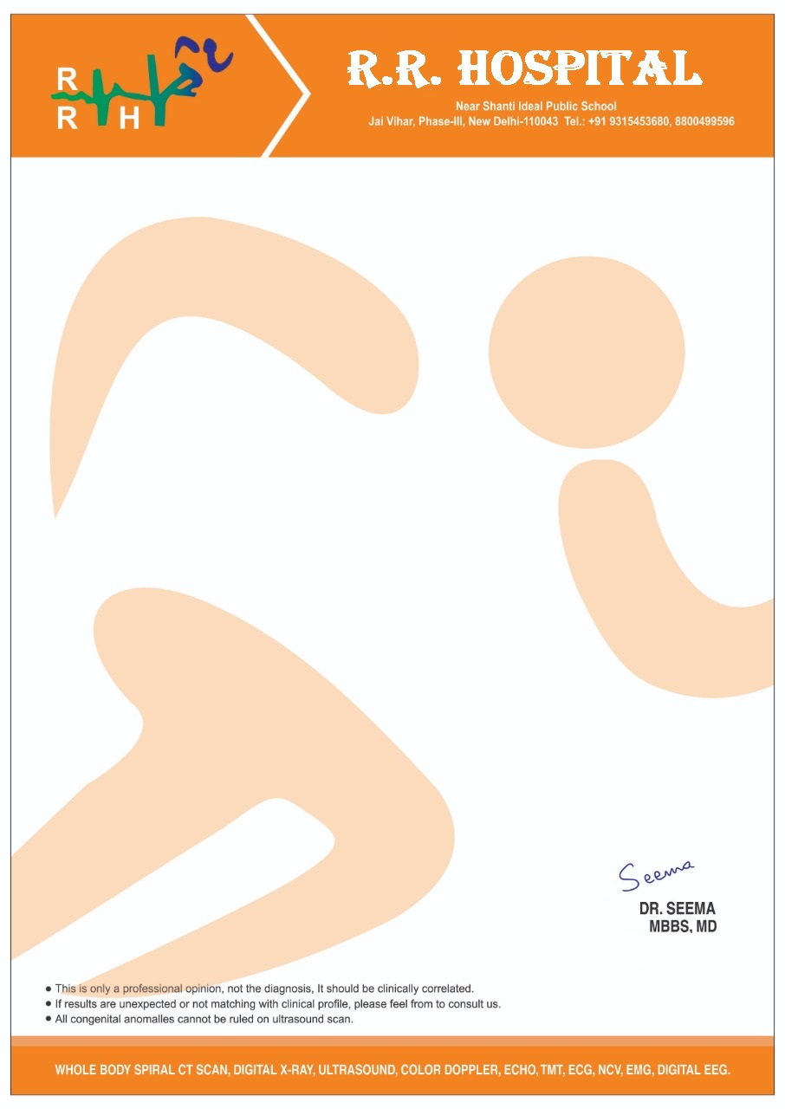

**MEDICAL CERTIFICATE OF FITNESS**

I have examined Master Anwit Kumar Son of Mr. Amit Kumar age 3years 5months , of R/o E-504 Street No-78 Mahavir Enclave-3rd New Delhi 110059 and certify that, he is free from deafness, defective vision (including colour vision) or any other infirmity, mental or physical and found him possessing good health. This certificate is being given to him for the purpose of School admission

Signature of Parent’s